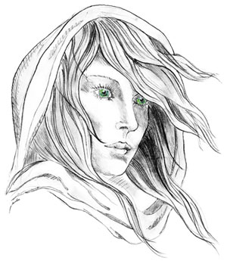
THE WHITE LADY
WORSTEAD
The Free house in the heart of Worstead
Pub, Restaurant, Luxury Bed & Breakfast and
Self-Catering Cottages

Starters
Hand Folded Spinach & Ricotta Tortellini w/ a Wild Garlic & Walnut Pesto £6
Peppered Semolina Calamari w/ Romesco £6
Ox Cheek & Bone Marrow Croquette w/ a Bourbon Glaze £6

Mains
8oz Burger, Cheddar, Bacon, House Chips, Onion rings & Gherkin Spears £12
Sausage & Mash w/ Crispy Shallots £12
Battered North Sea Cod, House Chips, Garden Peas & Chunky Tartar £14
Roast Lamb Rump, Romesco, Samphire, Anchovie Dauphinoise & Asparagus £16
Mac & Cheese w/ Shredded Ox Cheek & Parmesan Gratin £14
Hand Folded Ricotta Tortellini w/ Samphire & a Wild Garlic & Walnut Pesto £14

Sides
Chunky House Chips £3
Onion Rings £3
Fine Green Beans £3
Heritage Carrots £3

Desserts
Lemon Posset w/ a Seeded Biscuit £4
Sticky Toffee Pudding w/ Vanilla Ice Cream £4

All of our meat is locally sourced (Swannington farm to fork).

Management advises that food prepared here may contain or have come in contact with peanuts, tree nuts, soybeans, milk, eggs, wheat, shellfish or fish. Please ask a member of staff about the ingredients in your meal before placing your order. Thank you.

